MRM Mobile App Architecture Document
Revision History
Date | Version | Description
25/04/2018 | <1.0>

Table of Contents
1. Introduction 3
1.1 Purpose 3
1.2 Mock Screens 4
1.3 Use-Case View 4
1.4 Sequence Diagram 5
1.5 Features 5

Introduction
This introduction provides an overview of Meeting Room Management System’s Mobile App.

Purpose
This document provides an architectural overview of the Meeting Room Manager (MRM) mobile app. The primary purpose of MRM mobile app is to overcome the challenges faced in the web application and avoid many clicks in booking a meeting room.

Mock Screens
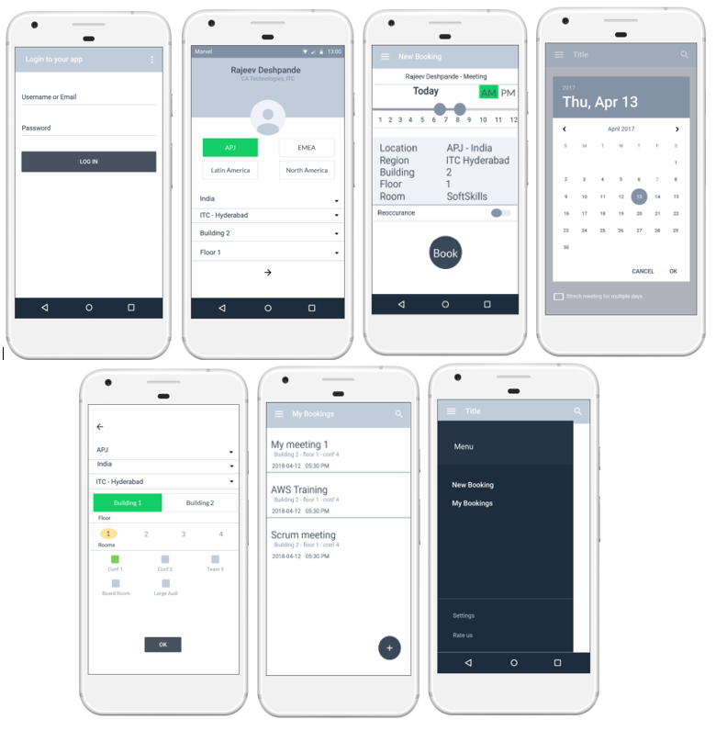

Use-Case View
The main purpose of the use case view is to define main drivers of the system, which are the system requirements. The general functionality of the MRM mobile app can be seen in the following diagram:
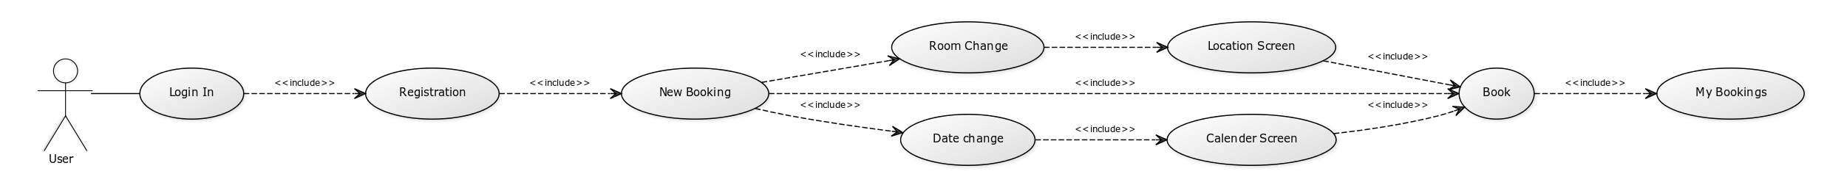

Sequence Diagram

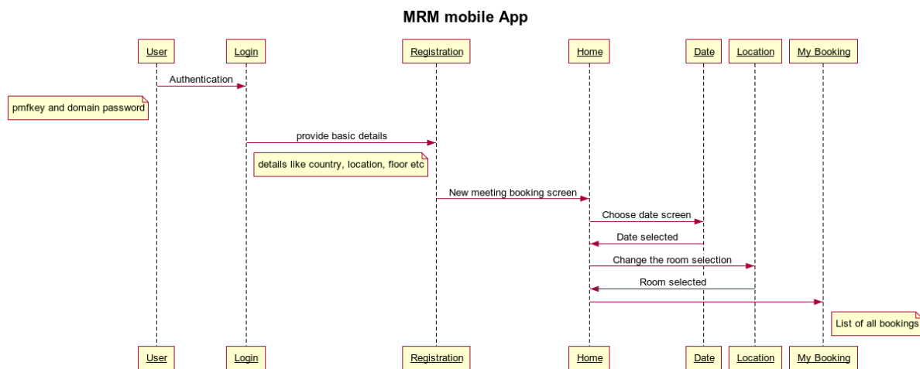

Features
AWS:
Dynamo DB
Lambda Functions
SNS

Other Features:
Layer 7 \API Gateway
Ionic Framework
Android SDK

